**LAB 8**

**PAGE REPLACEMENT ALGORITHM**

The page replacement algorithms we use in this lab are as follows:

1. Optimal replacement

2. FIFO replacement

3. LRU replacement

**For Optimal Page Replacement:**

#include <stdio.h>

int main() {

int no_of_frames, no_of_pages, frames[10], ref_string[30], temp[10], flag1, flag2, flag3;

int i, j, k, pos, max, faults = 0;

int flag = 0; // for hit if flag = 1 ; then hit else fault

printf("Enter number of frames: ");

scanf("%d", &no_of_frames);

printf("Enter number of pages: ");

scanf("%d", &no_of_pages);

printf("Enter page reference string: ");

for(i = 0; i < no_of_pages; ++i){

scanf("%d", &ref_string[i]);

}

for(i = 0; i < no_of_frames; ++i){

frames[i] = -1;

}

printf("\n==============================================================================\n" );

for(int i=0;i<no_of_frames; i++)

printf("frame[%d]\t",i );

printf("page fault" );

printf("\n==============================================================================" );

for(i = 0; i < no_of_pages; ++i){

flag1 = flag2 = 0;

for(j = 0; j < no_of_frames; ++j){

if(frames[j] == ref_string[i]){

flag1 = flag2 = 1;

flag = 1;

break;

}

}

if(flag1 == 0){

for(j = 0; j < no_of_frames; ++j){

if(frames[j] == -1){

faults++;

frames[j] = ref_string[i];

flag2 = 1;

break;

}

}

}

if(flag2 == 0){

flag3 =0;

for(j = 0; j < no_of_frames; ++j){

temp[j] = -1;

for(k = i + 1; k < no_of_pages; ++k){

if(frames[j] == ref_string[k]){

temp[j] = k;

break;

}

}

}

for(j = 0; j < no_of_frames; ++j){

if(temp[j] == -1){

pos = j;

flag3 = 1;

break;

}

}

if(flag3 ==0){

max = temp[0];

pos = 0;

for(j = 1; j < no_of_frames; ++j){

if(temp[j] > max){

max = temp[j];

pos = j;

}

}

}

frames[pos] = ref_string[i];

faults++;

}

printf("\n");

for(j = 0; j < no_of_frames; ++j){

printf("%4d\t\t", frames[j]);

}

if (flag == 0)

printf(" F" );

flag = 0;

}

printf("\n==============================================================================" );

printf("\n\nTotal Page Faults = %d\n", faults);

return 0;

}

**Output:**

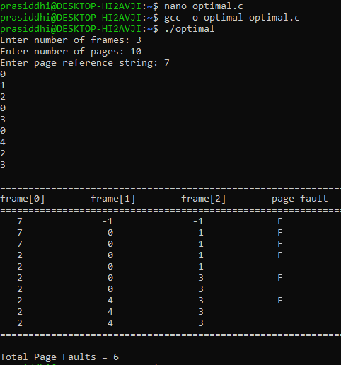

**For FIFO Replacement:**

#include <stdio.h>

int main() {

int num_pages, num_frames, page_faults = 0;

printf("Enter the number of pages: ");

scanf("%d", &num_pages);

int pages[num_pages];

printf("Enter the page reference string: ");

for (int i = 0; i < num_pages; i++) {

scanf("%d", &pages[i]);

}

printf("Enter the number of frames: ");

scanf("%d", &num_frames);

int frames[num_frames];

for (int i = 0; i < num_frames; i++) {

frames[i] = -1;

}

int oldest_frame = 0;

for (int i = 0; i < num_pages; i++) {

int page = pages[i];

int page_found = 0;

for (int j = 0; j < num_frames; j++) {

if (frames[j] == page) {

page_found = 1;

break;

}

}

if (!page_found) {

frames[oldest_frame] = page;

oldest_frame = (oldest_frame + 1) % num_frames;

page_faults++;

}

}

printf("Total page faults using FIFO algorithm: %d\n", page_faults);

return 0;

}

**Output:**

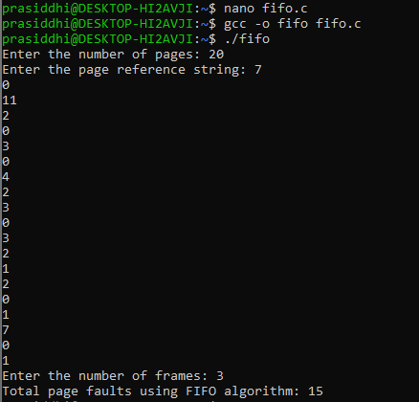

**For LRU Replacement:**

#include <stdio.h>

int main() {

int num_pages, num_frames, page_faults = 0;

printf("Enter the number of pages: ");

scanf("%d", &num_pages);

int pages[num_pages];

printf("Enter the page reference string: ");

for (int i = 0; i < num_pages; i++) {

scanf("%d", &pages[i]);

}

printf("Enter the number of frames: ");

scanf("%d", &num_frames);

int frames[num_frames];

int last_used[num_frames];

for (int i = 0; i < num_frames; i++) {

frames[i] = -1;

last_used[i] = -1;

}

for (int i = 0; i < num_pages; i++) {

int page = pages[i];

int page_found = 0;

for (int j = 0; j < num_frames; j++) {

if (frames[j] == page) {

page_found = 1;

last_used[j] = i;

break;

}

}

if (!page_found) {

int lru_frame = 0;

for (int j = 0; j < num_frames; j++) {

if (last_used[j] < last_used[lru_frame]) {

lru_frame = j;

}

}

frames[lru_frame] = page;

last_used[lru_frame] = i;

page_faults++;

}

}

printf("Total page faults using LRU algorithm: %d\n", page_faults);

return 0;

}

**Output:**

